# Too many shards alert of Pronto

1. Check the shards info from dev console: <https://esadsquality-kibanaslc.vip.ebay.com/app/dev_tools#/console>, by following request:

GET _cat/shards

Example result:

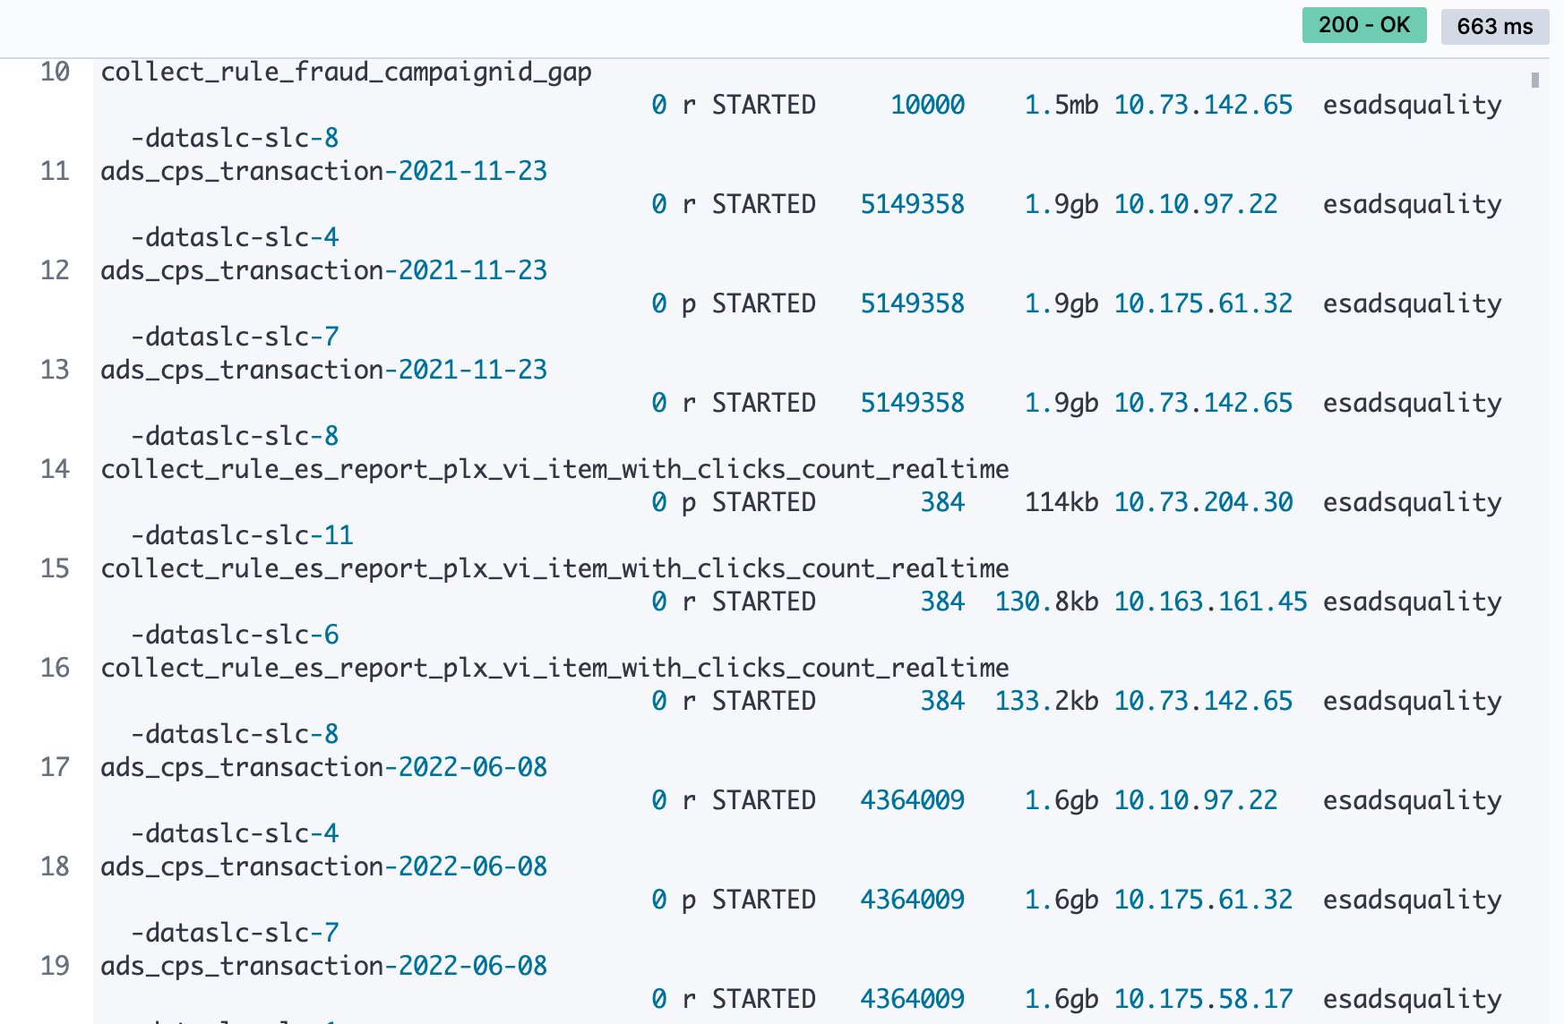

1. Find out the indexes with too many shards, ask the index owner for approval of deleting old data
2. Use "_delete_by_query" api to remove old data (this process could takes a lot of time, and you may need to write a script to do this)  
   Example:
3. POST /<index_name>/_delete_by_query
4. {
5. "query": {
6. "bool": {
7. "must": [
8. {
9. "range": {
10. "slot_timestamp": {
11. "gte": "2021-10-26T23:00",
12. "lt": "2021-12-27T23:00",
13. "time_zone": "-0700"
14. }
15. }
16. }
17. ]
18. }
19. }

}